APPLICATION PROCESSOR CARD

Hardware Requirement Specification
Rev-B

22-APR-13

Ownership Disclaimer
This document contains proprietary and confidential material that is the sole property of Compressor Controls Corporation. The information contained herein is intended for internal use by Compressor Controls Corporation employees and is not intended for distribution outside of the company. As an unpublished work of trade secrets, the recipient shall keep this document confidential. Any re-use, copying, or distribution, either in whole or in part, of this material without the express written consent of Compressor Controls Corporation is strictly forbidden.
Copyright © 2011 by Compressor Controls Corporation. All rights reserved.

Revision History

Rev. | Date | Revised By | Description
0.1 | 24-Mar-11 | Akhilesh Jaiswal | Initial Draft
0.2 | 30-Mar-11 | Akhilesh Jaiswal | - Common section applicable all the NGP cards removed  - Block diagram updated
A | 19th FEB 2013 | Ajesh John | - Updated for REVA requirement changes
B | 22ndAPR 2013 | Ajesh John | - Updated for REVB requirement changes

Approvals

Approved by: Date: _______________
Approved by: Date: _______________
Approved by: Date: _______________
Approved by: Date: _______________
Approved by: Date: _______________
Approved by: Date: _______________

TABLE OF CONTENTS

1 Introduction 5
1.1 Purpose 5
1.2 Audience 5
1.3 Scope 5
1.4 Acronyms 5
1.5 References 6
2 General Description 7
2.1 System Overview 7
2.2 Product Functions 8
2.3 Block Diagram 9
3 Electrical Requirements 10
3.1 Processor 10
3.2 Main (DDR) Memory 10
3.3 Flash Memory 10
3.4 EEPROM Memory 10
3.5 SD/MMC Card Interface 10
3.6 Real Time Clock 10
3.7 IEEE 1588 11
3.8 10/100 Ethernet Port 11
3.9 EtherCAT Backplane Interface 11
3.10 Serial ports 11
3.11 APP-APP Communication 12
3.12 Hotswap 12
3.13 Load share 12
3.14 Temperature Sensors 12
3.15 Voltage Monitoring Circuit 12
3.16 Voltage Sequencing Circuit 12
3.17 IES Card Detection 12
3.18 Power 12
3.19 Front Panel LEDs 12
3.20 Debug/ Diagnostic 13
3.21 Components 14
3.22 Connectors 14
4 Mechanical Requirements 15
4.1 4.1 PCB 15

Introduction

Purpose
The purpose of this document is to capture the hardware requirements for APP card (Application Processor card) which is used as main processing unit on New Generation Platform (NGP) control system.

Audience
This document is meant to be used by the project team members as the basis and controlling document for the design and development of APP card.

Scope
Application Processor Card is a Freescale QorIQ processor based design which will be used as main processing unit for New Generation Platform control system. This document defines the product requirements to which hardware has to be designed and manufactured. This document also covers system level requirements applicable to APP card. This document doesn’t cover the firmware/ software related requirements.

Acronyms
Acronym | Definition
APP | Application Processor Card
COP | Common-on Processor
DDR | Dual Data Rate
DIMM | Dual in line Memory Module
ESD | Electrostatic Discharge
FTC | Field Terminal Card
I2C | Inter IC
IC | Integrated Circuit
IES | Integrated Ethernet Switch
IOP | Input Output Processor
JTAG | Joint Test Access Group
NGP | New Generation Platform
PCB | Printed Circuit Board
PCC | Power Conversion Card
RoHS | Restriction of Hazardous Substances
RTC | Real Time Clock
SPI | Serial Peripheral Interface
UART | Universal Asynchronous Receiver/ Transceiver
USB | Universal Serial Bus

References
[1] Detailed Functional Specification for NGP Hardware, Part 1, Rev-3
[2] System Study for New Generation Platform Electronics and Bring-up, Rev-1
[3] P1021 QorIQ Integrated Processor Hardware Specifications, Rev-L
[4] P1021 QorIQ Integrated Processor Reference Manual, Rev-3

General Description

System Overview
New Generation Platform (NGP) is a fully redundant, duplex, highly available, fault tolerant control system intended to handle a number of digital, analog and frequency IOs in industrial applications. Below is the system block diagram of NGP.

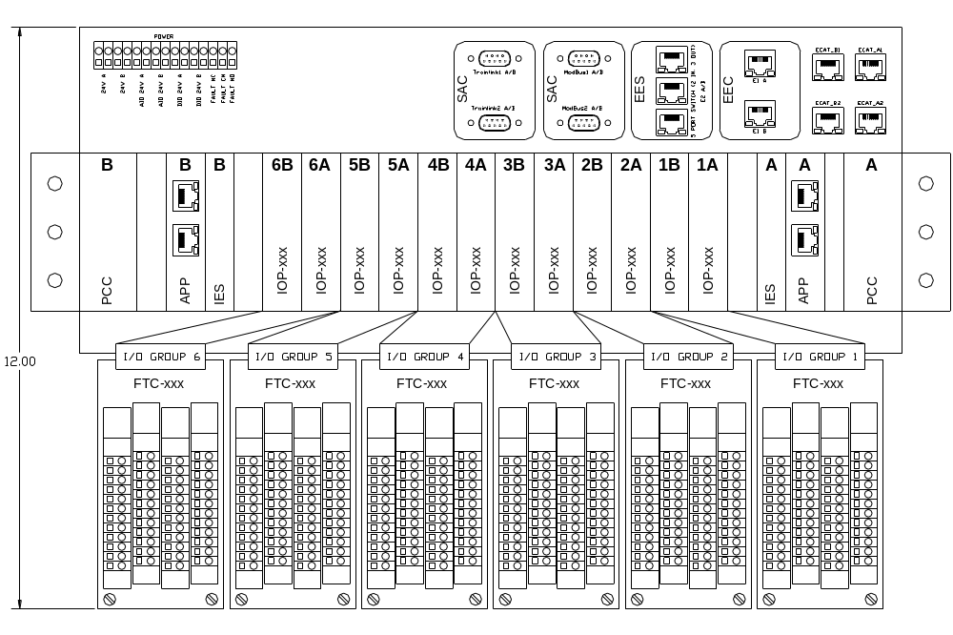
Here is the list of different electrical components in the system and their brief description.

APP
This is the main processing unit in the system. This runs the main application and does monitoring and control of the overall system. There will be a maximum of 2 such cards in an NGP system.

IOP (Digital and Analog)
These are the processors cards which handle digital, analog and frequency IOs. There will be a maximum of 12 such cards in an NGP system.

IES
This is the EtherCAT switch card used to interface between different APP and IOP modules. There will be a maximum of 2 such cards in an NGP system

PCC
This is power conversion card. The input power (redundant 24VDC) to the system first comes to this card. This card does the oring, filtering, protection and other voltage conversion. There will be a maximum of 2 such cards in an NGP system

FTC (Digital and Analog)
These ate the field terminal cards where all the field loads are connected to. These are electrically interfaced to IOP cards. The number of FTC in an NGP system is same as the number of IOP card

CAC
These are the set of communication (Ethernet, RS-485) cards used for interface to the external devices

Backplane
All the above mentioned boards plug in backplane and communicate to each other over it.

Product Functions
APP is the main processing unit in the system. This is based on Freescale QorIQ processor. It runs the main application and does monitoring and control of the overall system. It implements EtherCAT master to communicate to IOPs in the system. It also implements 10/100 Ethernet and RS-485 ports for communication to external devices.

Block Diagram

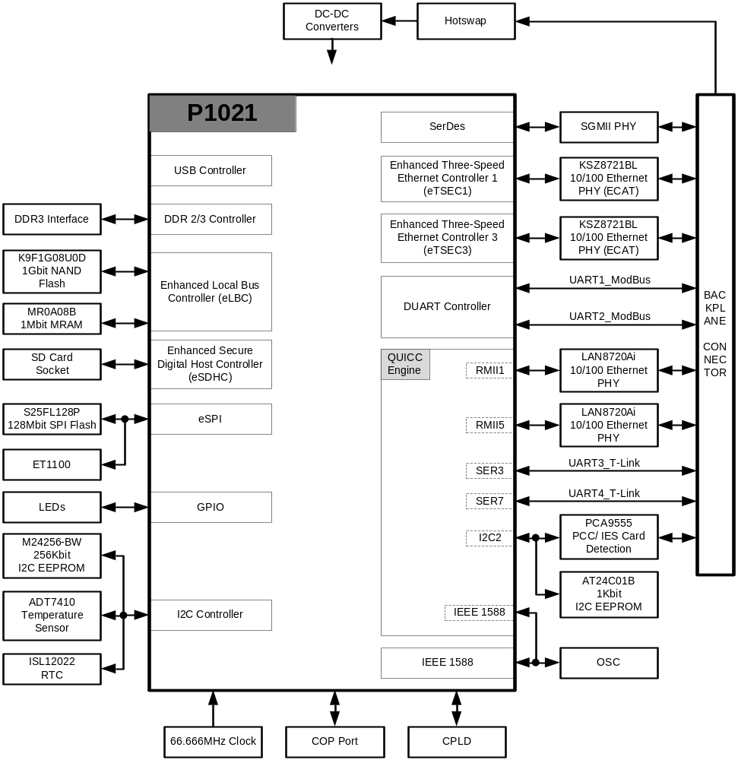

Electrical Requirements

Processor
    - Freescale QorIQ communication processor P1021 shall be implemented as main processing unit
    - Design shall support processor core frequencies of 533MHz, 667MHz and 800MHz

Main (DDR) Memory
    - 512MBytes, DDR3 Interface shall be implemented as main memory
    - Design shall support 1 GB DDR3 Interface also
    - ECC shall be supported on main memory

Flash Memory
    - 1Gbit NAND Flash shall be implemented with an option to assemble 512Mbit/ 256Mbit/ 128Mbit part.
    - 1Mbit Everspin MRAM shall be implemented with an option to assemble 4Mbit part
    - 128Mbit SPI serial Flash shall be implemented

EEPROM Memory
    - 256Kbit EEPROM shall be implemented as boot sequencer EEPROM.
    - 2Kbit EEPROM shall be implemented as board EEPROM

SD/MMC Card Interface
    - SD/MMC card interface shall be implemented
    - A single connector shall be used for both SD and MMC card
    - SD/MMC card connector shall not be placed on the front panel
    - ESD protection shall be provided for SD card interface

Real Time Clock
    - RTC shall be implemented on the card
    - RTC shall support Seconds, Minutes, Hours, Day, Date, Month and Year
    - RTC circuit shall have battery back-up

IEEE 1588
    - IEEE 1588 shall be implemented

10/100 Ethernet Port
    - Two 10/100 Ethernet MDI ports shall be implemented
    - These two Ethernet MDI ports shall be routed to the backplane connector without magnetic

EtherCAT Backplane Interface
    - Two EtherCAT ports shall be implemented
    - These two EtherCAT ports shall be routed to the backplane connector

Serial ports
    - Two Modbus RTU RS-485 ports shall be implemented
    - Modbus RTU RS-485 ports shall support 4-wire (full duplex)/ 2-wire (half duplex) implementation
    - Modbus RTU RS-485 ports shall support 56kbps data transfer rate
    - Modbus RTU RS-485 ports shall be routed to backplane connector
    - Each Modbus port shall contain two Rx lines; one for Full Duplex operation and one for Half duplex operation.
    - Two Trainlink RS-485 ports shall be implemented
    - Trainlink RS-485 ports shall support 4-wire (full duplex)/ 2-wire (half duplex) implementation
    - Trainlink RS-485 ports shall support 315kbps data transfer rate
    - Trainlink RS-485 ports shall be routed to backplane connector
    - Each TrainLink port shall contain two Rx lines; one for Full Duplex operation and one for Half duplex operation.
    - Each TrainLink port shall use External clock for Rx data processing. This shall be generated using a CPLD. The incoming Rx data from Backplane shall be synchronized with this external clock.

APP-APP Communication
    - An APP-APP communication port shall be implemented through SGMII
    - This port shall be routed to the backplane connector

Hotswap
    - APP card shall be hotswapable

Load share
    - The APP board shall share cureent from both input voltages ie 6.5VA and 6.5VB coming from the backplane.

Temperature Sensors
    - Processor temperature sensor shall be implemented.

Voltage Monitoring Circuit
    - A voltage monitoring circuit shall be implemented to measure all the on board derived voltages.

Voltage Sequencing Circuit
    - A voltage sequencing circuit shall be implemented to turn on all on the board derived voltages is proper sequence.

IES Card Detection
    - IES card physical insertion and removal detection logic shall be implemented.
    - IES card physical detection logic shall identify the slot (A or B) the board is inserted to or removed from.

Power
    - The APP Board shall be powered using 6.5V generated from PCC Board. The APP board shall share the current from both PCCs almost equally.

Front Panel LEDs
    - Logo LED
Color | Control
Blue | Hardware

    - Active LED
Color | Control
Green | Software

    - Healthy/ Ready LED
Color | Control
Green | Software

    - Alarm LED
Color | Control
Yellow | Software

    - Fault LED
Color | Control
Red | Hardware

    - Learn LED
Color | Control
Green | Software

    - CPU Activity LED
Color | Control
Green | Software

    - Communication LEDs
Color | Control
Green | Hardware

Debug/ Diagnostic
    - COP/ JTAG Port
Common on-chip processor (COP)/ JTAG port shall be implemented for connection to emulator for system debugging/ programming. Position of the COP/ JTAG connector should be such that it is easily accessible when the card is installed in the system. This connector shall not be mounted on front panel
    - Diagnostic RS-232 Port
A diagnostic RS-232 port may be implemented on board using a 3-pin header depending on the feasibility. The position of the header should be such that it is easily accessible when the card is installed in the system. This header shall not be mounted on front panel.
    - User LEDs
Four user LEDs as defined below shall be implemented for debug purposes.

LED | Color | Control
User LED1 | Green | Software
User LED2 | Green | Software
User LED3 | Green | Software
User LED4 | Green | Software

    - Manual Reset Switch
A manual reset switch shall be implemented for development/ debug purpose. The position of the reset switch should be such that it is easily accessible when the card is installed in the system. This header shall not be mounted on front panel.
    - Test Points
Clip-on test points shall be implemented for key signals including all power and ground rails. The test points should be reasonably spaced to prevent test connection shorting while testing.

Components
    - All the components shall meet industrial temperature ratings
    - All other parts can be either RoHS or Non-RoHS

Connectors
    - The Backplane connectors shall be following P/Ns
Make | Part No | Description
FCI | 10045267-101LF | 72-PIN Air-Max
FCI | 10039851-111LF | 54-PIN Air-Max
FCI | 10073379-001LF | 4-PIN Power connector
FCI | 10045597-101LF | GUIDE PIN

Mechanical Requirements

4.1 PCB
4.1.1 PCB Form Factor
The size of the APP baord shall be 161.82mm x 127mm
4.1.2 PCB Thickness
The PCB thickness of the APP Board shall be 1.6mm.

